MACH4METAL

metalworking machinery
Transito 21
6909 DA BABBERICH Netherlands
Tel. +31 (0)316-247123
Fax: +31 (0)316-247956
info@mach4metal.com
www.mach4metal.com

Bank No : 66.52.13.883
IBAN : NL33 INGB 0665 2138 83
BIC : INGBNL2A

BRIDGEPORT VMC 800 30 Digital

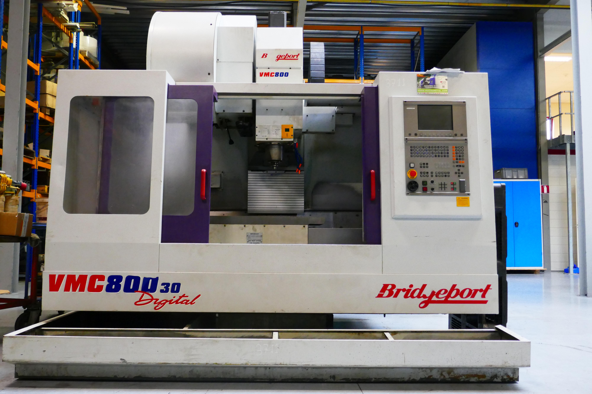
- Make : Bridgeport uk
- Typ : VMC 800 30 Digital
- No : 104404
- YOP : 2000 . 04

- Capacity – Travel
- X - Travel : 800
- Y - Travel : 510
- Z - Travel : 510

- Table dimensions:
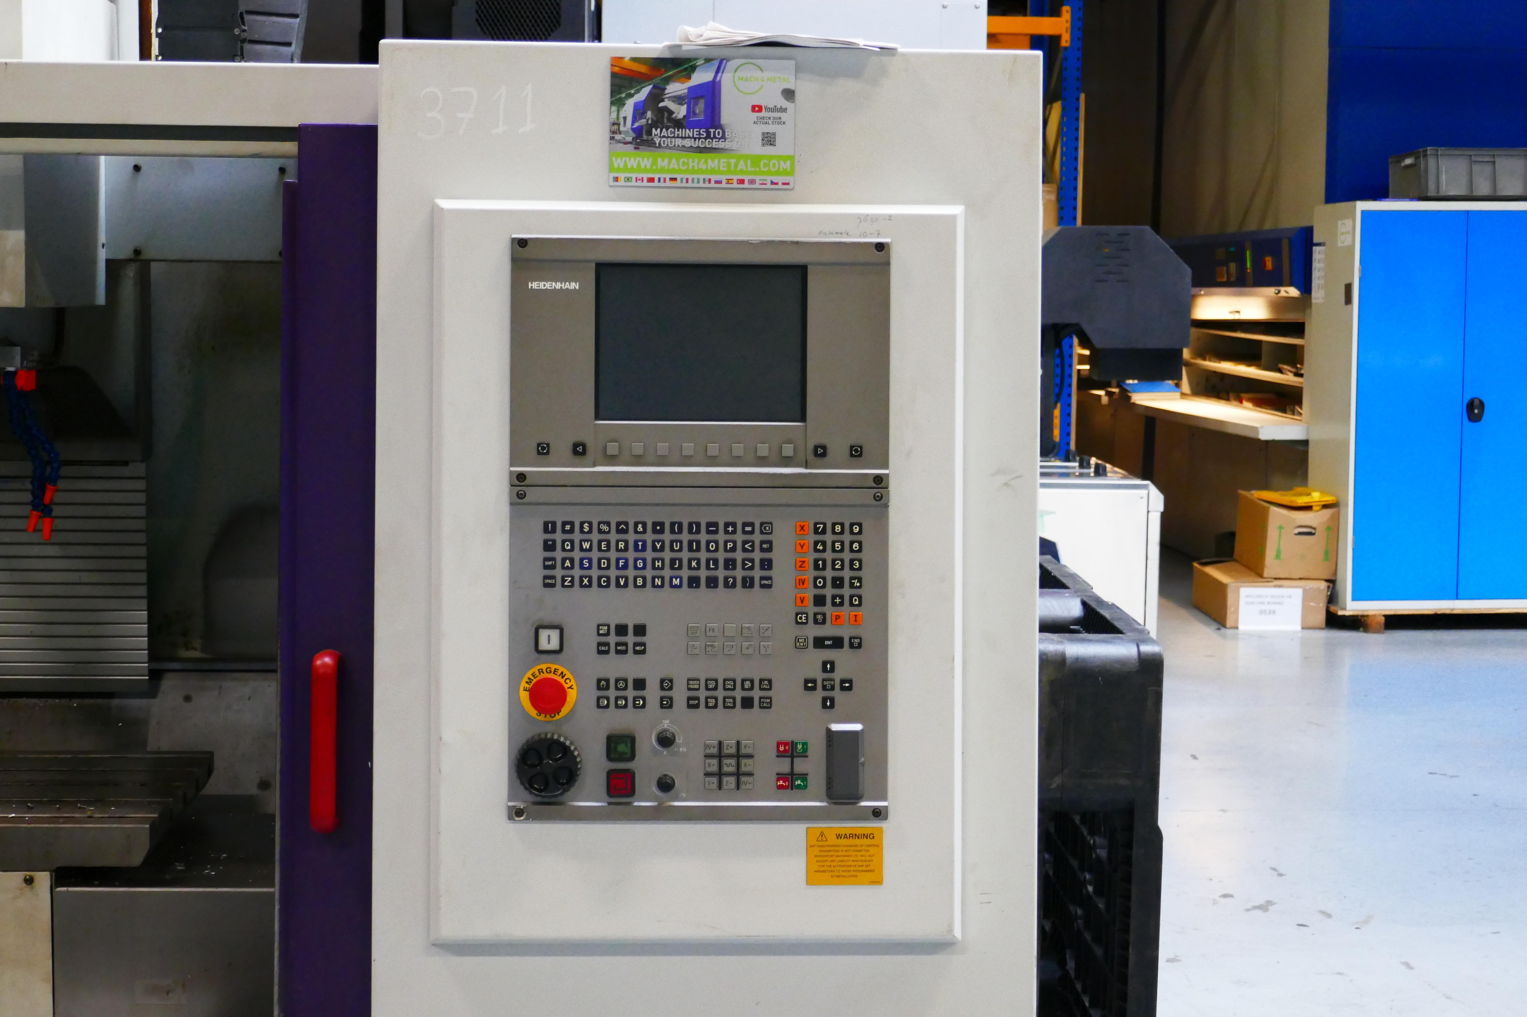
- Length : 1.000
- Width : 490
- Load Kg : 750

- Rapid traverse X - Y: 40.000 mm
- Rapid traverse Z : 25.000 mm

- Spindle : BT 40
- Speeds : 10.000
- Spindle power : 11 kW
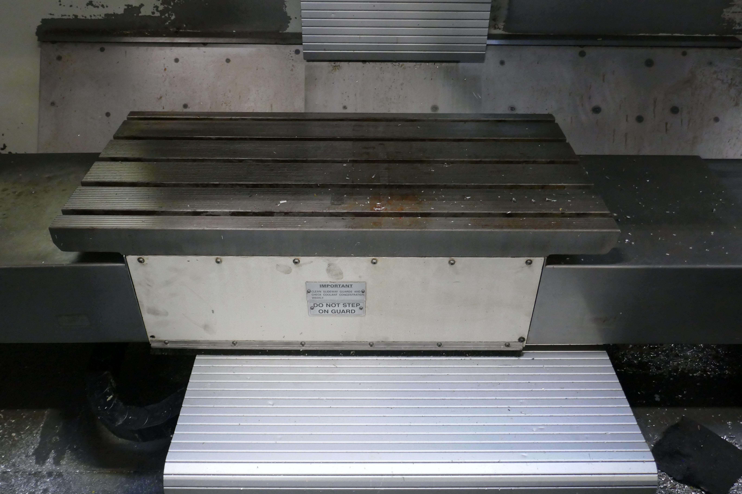
- Dimensions:
- Length : 2.960
- Width : 2.168
- Height : 2.576
- Weight : 4.620 Kg

- CNC HeidenHain TNC 426
- ATC with 30 tools

Please Note: The above information has been obtained to the best of our ability and belief from, and from the manufacturers where possible. It is given in good faith, but its accuracy can not be guaranteed. Accordingly, it will not form a representation or constitute contractual terms. We advise you to check any vital details!

